When Beta = 0.01 Puppy image:

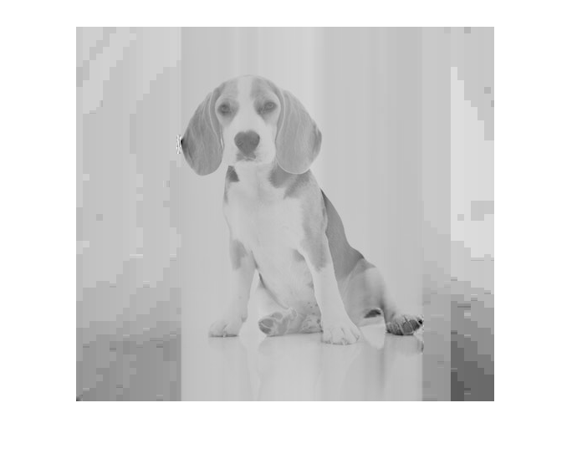

When Beta = 0.05 Puppy Image:

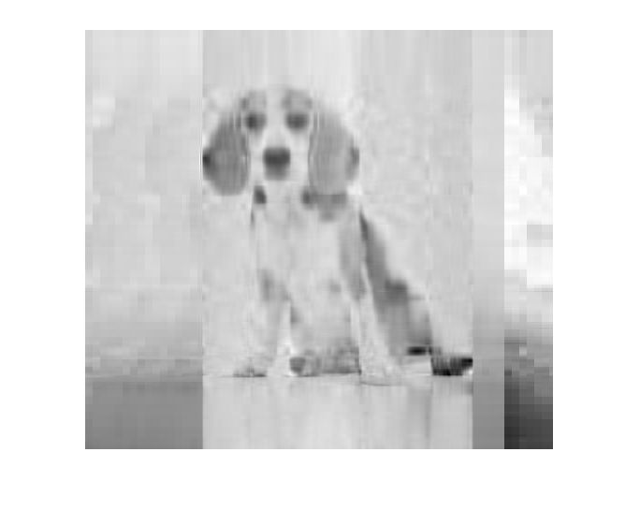

When B = 0.1 Puppy Image:

